**Python Workshop – November 2023**

**Day 1:**

**Module 1: PyCharm**

PyCharm is an integrated development environment (IDE) for programmers, which can be downloaded and installed from <https://www.jetbrains.com/help/pycharm/installation-guide.html> . There are many other python software packages that can be used to run python scripts, but for this journey we will stick to PyCharm. Start by opening PyCharm Community or Professional App. Then

1. A screenshot of a computer screen

   Description automatically generatedCreate a new project: File -> New Project…
2. 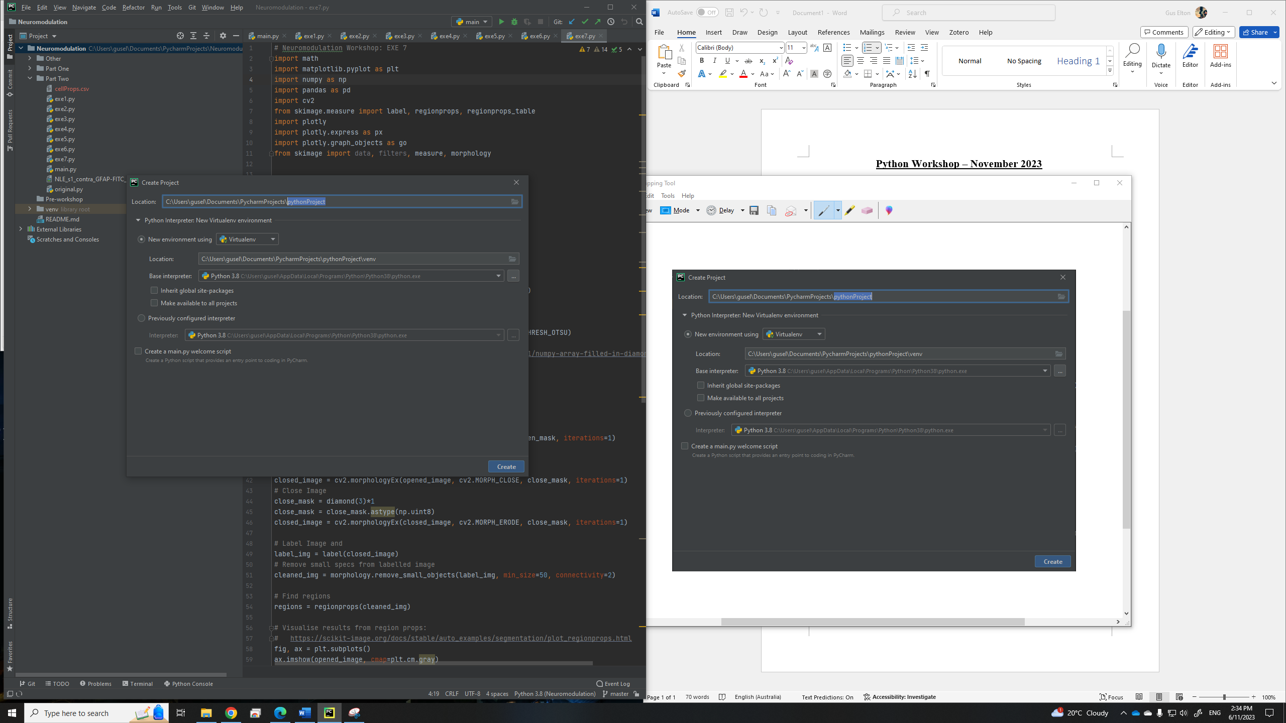Rename Python Project by typing the name where the highlighted font is below.
3. Tick the ‘create a main.py welcome script’ and select create in the bottom right-hand corner of the dialogue box.

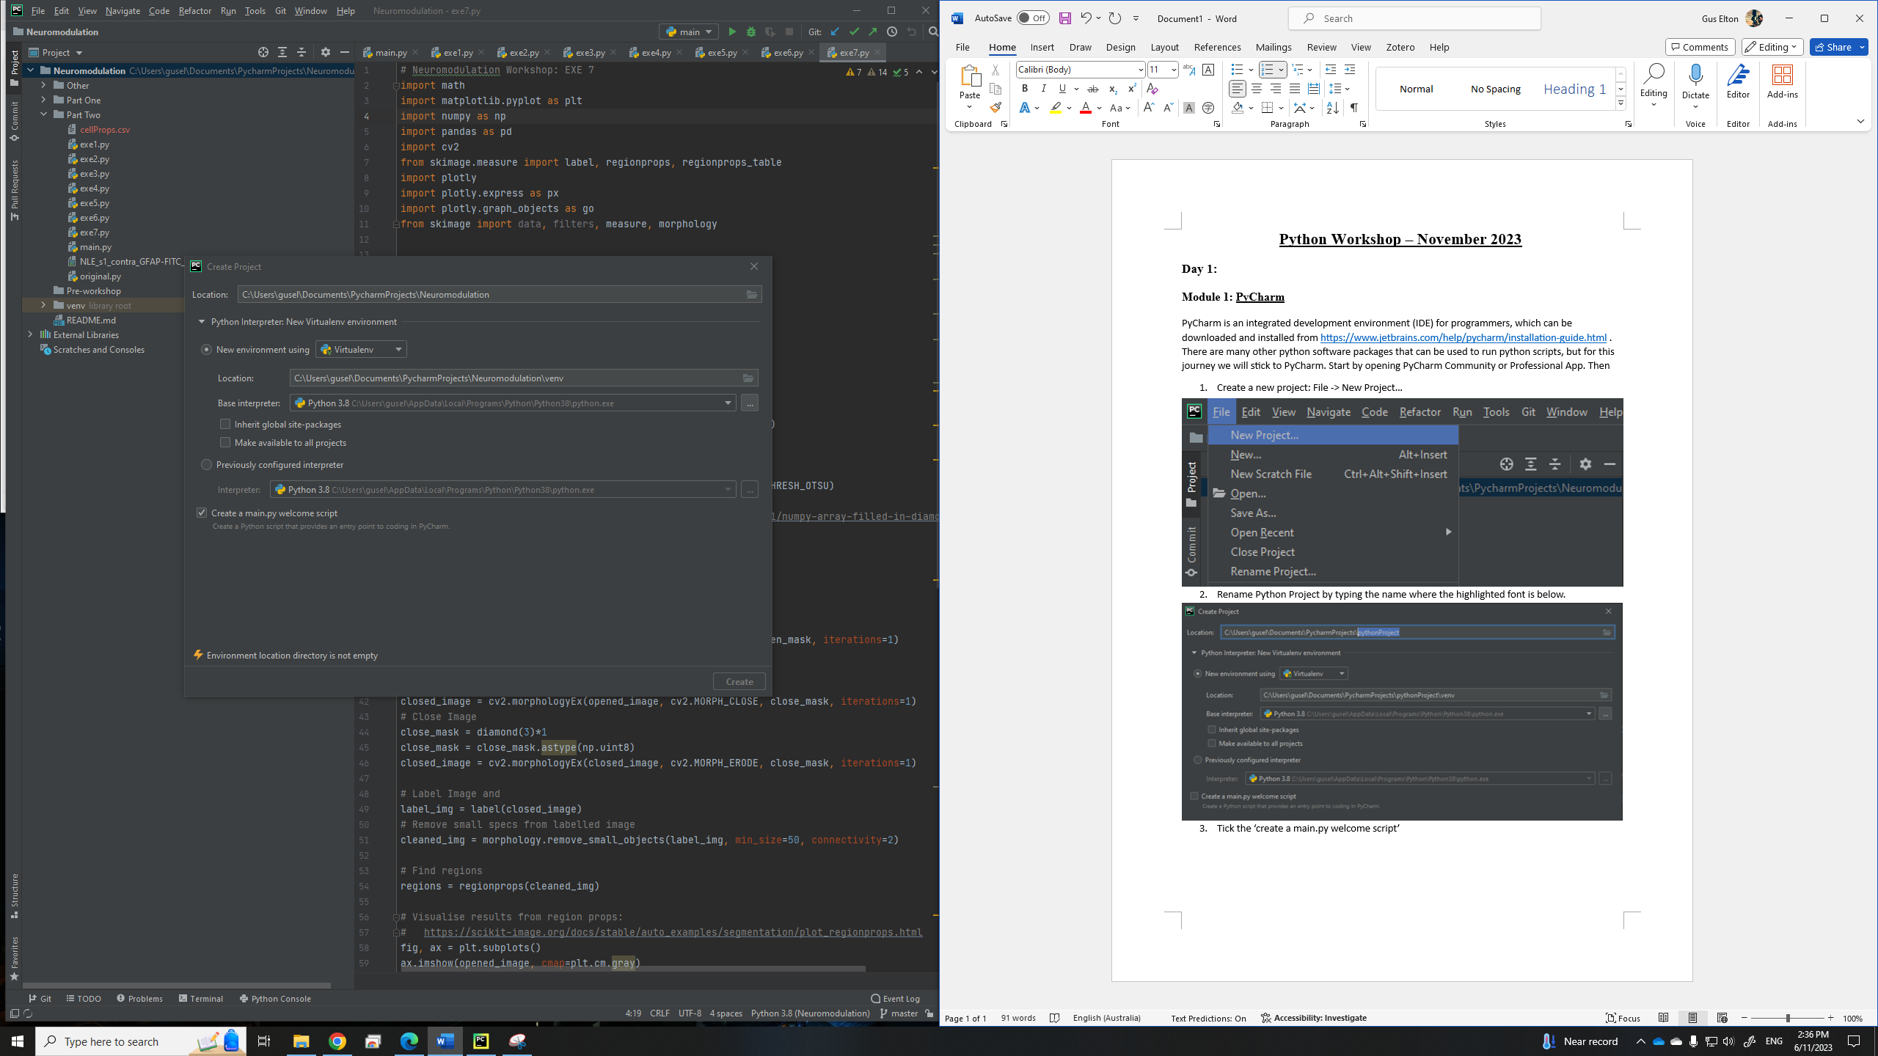

A main.py script should now appear in front of you with some example code as follows. Try running the script by clicking the play button.

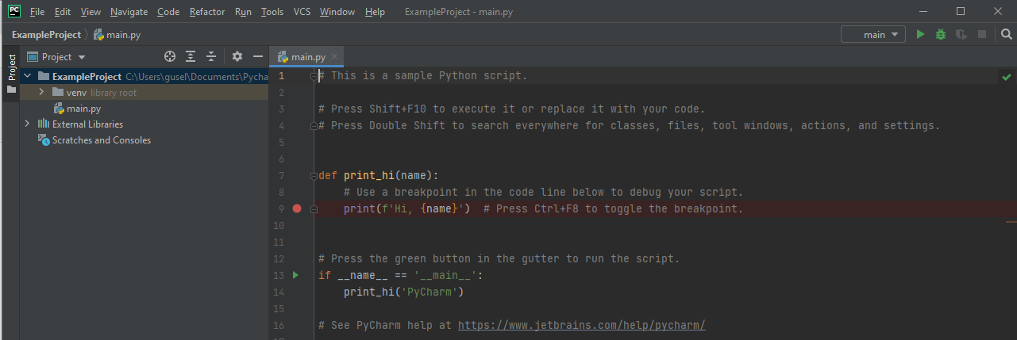

Notice that there are different Tabs (see figure below):

* Script/editor tab: where you can edit your code.
* Project tab lists the current project/working directory and files
* Problems: when you run your code problems/warnings will appear here.
* Terminal/console: you can run commands or code directly from the computer terminal or python console (we will not be doing this)
* TODO tab: you can create items for you to complete which will be listed here.

**Module 2: GitHub Repository**

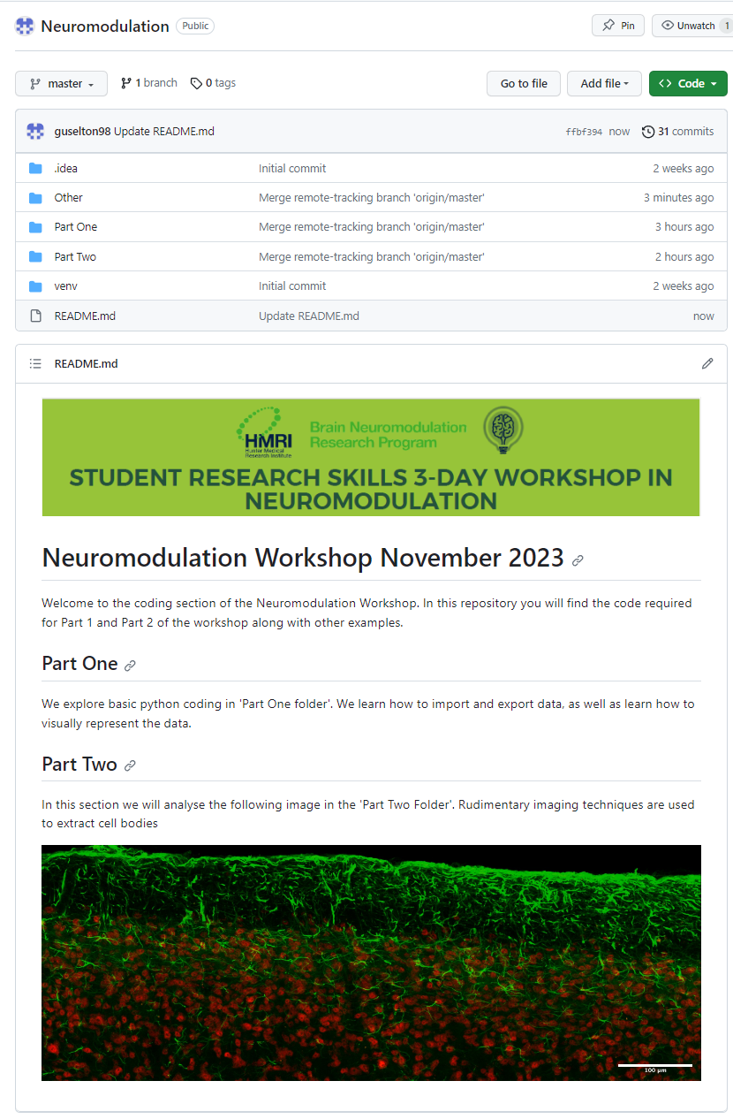In the coding sessions we will be following the examples outlined in the GitHub repository: <https://github.com/guselton98/Neuromodulation> .